Practical – 4

JavaScript DOM Manipulation, Event Handling, and UI Interactivity
Problem Definition : Add dynamic UI components such as collapsible FAQ, modal popup, image/content slider, notification banner, hamburger menu, and light/dark theme switcher using JavaScript.
A. THEORY
1. How are DOM elements selected and modified?
DOM elements are selected using methods like getElementById() and querySelector(). Their content, style, or attributes can then be modified using JavaScript.
2. Are event listeners attached correctly?
Yes. Event listeners such as click are attached to the required buttons and elements to perform actions when the user interacts with the page.
3. Is localStorage used for remembering theme choice?
Yes. localStorage stores the user's selected theme, such as light or dark mode, so the same theme can be applied when the page is opened again.
4. Does interactivity improve usability without breaking accessibility?
Yes. JavaScript interactions make the website easier to use while keeping buttons, navigation, text, and other elements accessible to users.

References
- MDN Web Docs – DOM Introduction
- MDN Web Docs – EventTarget.addEventListener()
- MDN Web Docs – Window.localStorage
- W3C – Web Accessibility Initiative (WAI)

B. Implementation/ Output/Result


C. Evidence of Work (Screenshots)

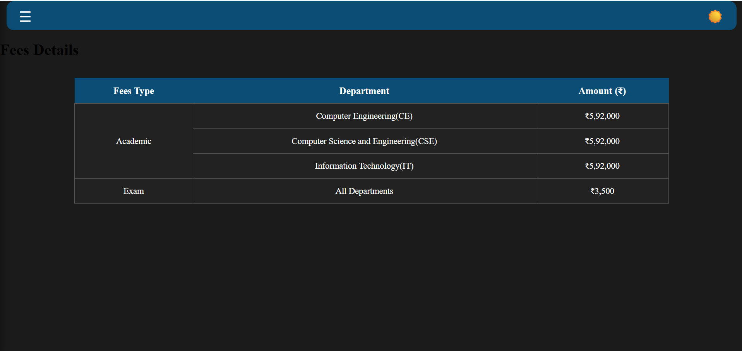


D. GitHub Repository Link
https://github.com/NencyNVagadiya/Student-Hub-portal/blob/main/contact.css

E. Challenges Faced:
“I faced difficulty in handling JavaScript events and making different UI components interactive, especially the hamburger menu, dark/light mode, modal popup, and collapsible sections.”
F. Learning Outcomes:
Students will apply JavaScript to enhance user experience and client-side interactivity.

G. Faculty Remarks:

